HHC-NET2D manual
Product description
1、Support TCP server, TCP client, UDP
2、Supporting 4 client connections in the TCP server.Assume that the local port is 5000.Port 5000,5001,5002,5003 can be connected to the TCP client.
3、Support TCP MODBUS protocol
Control command
1、Sent “on1”to the HHC-NET2D will turn on the First relay
2、Sent “on2”to the HHC-NET2D will turn on the Second relay
3、Sent “off1”to the HHC-NET2D will turn off the First relay
4、Sent “off2”to the HHC-NET2D will turn off the Second relay
timing control
Sent “on1:01”to the HHC-NET2D.The First relay will be close after one second turning on.01 means a delay of 1 second.Delay range from 01 to 99 seconds.
Parameter configuration
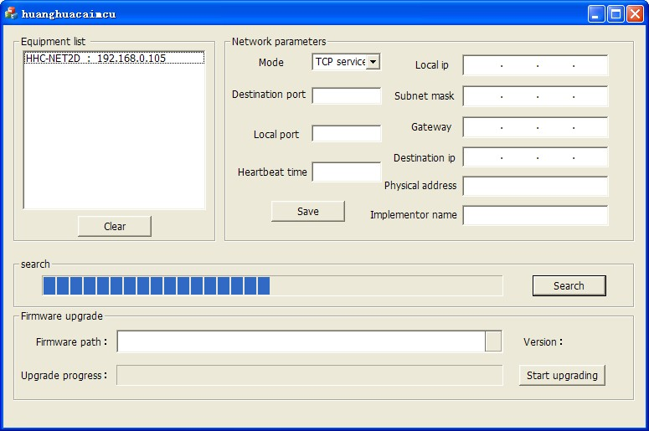
Click search button,It is will search for devices within the local area network.
Double click the device that has been searched.The parameters that will be read to the device are shown below.
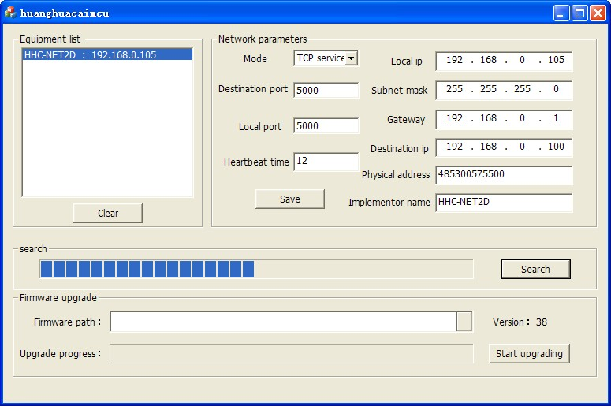

The Time Heartbeat option to detect the timing of the device to receive data.
Unit is 5 seconds.The above setup means that if you do not receive the control command over 2 minutes, the device will re initialize the network.

Restore factory settings
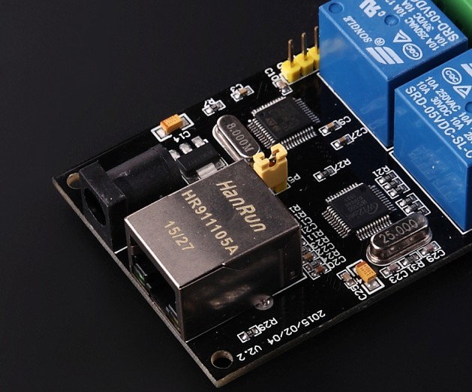
Dial out the hat of P5,Re power supply.It will restore factory settings.The default parameters are shown in the following diagram.

